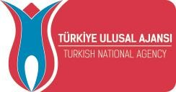

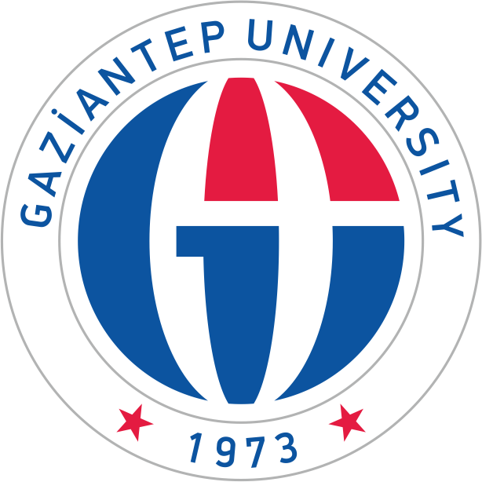

Erasmus+
KA107-International Credit Mobility (ICM)
The University of Gaziantep (GAUN), Turkey

Guide For
Partners & Applicants

www.gantep.edu.tr
incetahtaci@gantep.edu.tr

CONTENT
- ABOUT ERASMUS + ICM 3
- ERASMUS + ICM COORDINATOR & PARTNERS 4
- GRANTS 6
- SELECTION PROCEDURE 7
- HOW TO APPLY- STUDENTS 8
- HOW TO APPLY-STAFF 11
- FURTHER INFORMATION 12

ABOUT ERASMUS + ICM

30 years ago, Europe funded the Erasmus Programme which has enabled over three million European students to spend part of their studies in another higher education institution throughout Europe. Erasmus+ now opens up these opportunities, allowing mobility from and to other parts of the world.
International Credit Mobility (ICM) supports the mobility of individuals enrolled or employed in a higher education institution (HEI), from a Programme Country to a Partner Country or vice versa. ICM promotes full academic recognition of studies and supports cross-border cooperation between higher education institutions. It brings students the possibility to study abroad with credit recognition at the sending university.
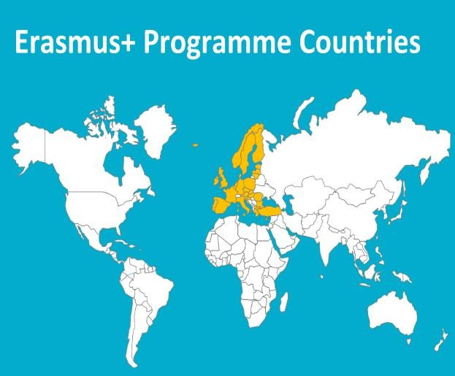
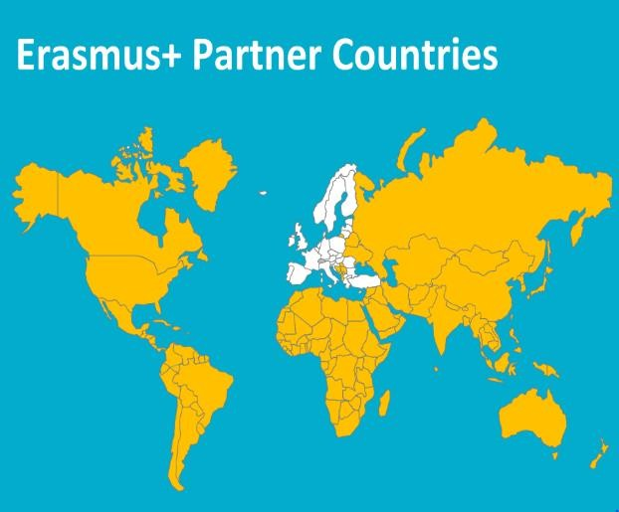
Student mobility for studies, open to short cycle, first cycle (Bachelor or equivalent) or second cycle (Master or equivalent) students, as well as third cycle doctoral candidates. The mobility period can last from 3 months (or one academic term) to 12 months.
Staff mobility for teaching for academic staff and invited staff from non-academic organizations to teach at a partner higher education institution (HEI) abroad. The mobility period is 5 days + 2 travel days.
Staff mobility for training for teaching and non-teaching staff in the form of training events abroad (excluding conferences), job shadowing, observation periods and/or training at a partner HEI. The mobility period can last from 5 days to 2 months. This activity also supports
the mobility of staff from Partner Country HEIs to train at a non-academic organization located in a Programme Country.

Roles and responsibilities
Participating organisations involved in the mobility project take on the following roles and responsibilities:
- The applicant organisation (always the Programme Country HEI) submits an application to its NA on behalf of its partner(s). The applicant can also apply on behalf of a consortium of several partners from the same Programme Country.
- Once selected the beneficiary organisation (always the Programme Country HEI) signs and manages the grant agreement, and reports at the end of the project. The beneficiary is financially responsible for the entirety of the grant.
- The sending organisation (from either a Programme or a Partner Country) is responsible for selecting the students and staff and sending them abroad. This includes preparation, monitoring and recognition activities.
- The receiving organisation (from either a Programme or a Partner Country) hosts the students and staff from abroad, providing support during their stay.

OUR ERASMUS + ICM PARTNERS

The University of Gaziantep is coordinator of Erasmus+ ICM Project with University of The Gambia, Gambia and North Caucasus Federal University, Russia for 2018 call. Students, teaching and administrative staff from Gambia and Russia may involve in ICM project with the University of Gaziantep vice versa.

Type of mobility:
Under the contract only Student Mobility for Studies (SMS), Staff Teaching and Training Mobilities are approved!
Duration of the Project: 26 months
Start date: 01/06/2018
End date: 31/07/2020
Contract number: 2018-1-TR01-KA107-056655

Partner Institutions: University of The Gambia (Gambia), North Caucasus Federal University (Russia)

Gambia
Incoming in total | 2
Outgoing in total | 2
Type of Activity |  | Participant
Teaching Activity | incoming | 1
Student Mobility | incoming | 1
Teaching Activity | outgoing | 1
Training Activity | outgoing | 1

Russia
Incoming in total | 2
Outgoing in total | 2
Type of Activity |  | Participant
Teaching Activity | incoming | 1
Student Mobility | incoming | 1
Teaching Activity | outgoing | 1
Student Mobility | outgoing | 1

GRANTS

Mobility of students to/from partner countries

Origin | Destination | Monthly Allowance
The University  of Gaziantep | Partner Country | 700 €
Partner Country | The University  of Gaziantep | 800 €

Mobility of teaching and administrative staff to/from partner countries

Origin | Destination | Daily Allowance
The University  of Gaziantep | Partner Country | 180 €
Partner Country | The University  of Gaziantep | 140 €

Travel grant for students and staff

The only contribution to the travel expenses (round trip) is determined by the distance between the place of study / work and the place where the activity is carried out, as follows:

Distance in kilometers | Travel grant for round-trip
< 100 km | 20 € per participant
100 - 499 km | 180 € per participant
500 - 1999 km | 275 € per participant
2000 - 2999 km | 360 € per participant
3000 - 3999 km | 530 € per participant
4000 - 7999 km | 820 € per participant

8000 km | 1.500 € per participant
Travel distances must be calculated using the distance calculator provided by the European Commission:
http://ec.europa.eu/programmes/erasmus-plus/tools/distance_en.htm

Tuition Fee

Students do not pay any tuition fees to the receiving institution during the programme, but they continue to pay the obligatory tuition fees to their sending institutions if are there any.
They do not pay any extra fees to the receiving institution within the scope of the exchange programme.

SELECTION CRITERIA

Eligibility assessment of all applications will be carried out by the sending university but receiving institution must be involved. The selection must be fair, transparent and well-documented. The sending and the receiving institution should have a common understanding regarding selection of participants and should have set a basic timeline.
For Students;

  - To be studying at associate’s degree, bachelor’s degree, master’s degree or PhD degree programmes at a higher education institution,
  - The student should have at least 30 ECTS course load,

  - Grade Point Average (GPA) of associate’s degree and undergraduate students must be at least 2,20 out of 4,00,
  - Grade Point Average (GPA) of graduate students (MA, PhD) must be at least 2.50 out of 4,00,
  - 50% language score + 50% GPA (grade point average)

  - If the student has a disability, s/he should be prioritized.

For Staff;

- The staff should have at least B1 level competence in English language.

- If the staff has a disability, s/he should be prioritized.

HOW TO APPLY - STUDENTS

If you would like to be an Erasmus+ student at The University of Gaziantep, your sending university should have an active Erasmus+ Inter-institutional Agreement in the relevant field of study at GAUN. If two institutions have an agreement, then you need to be nominated by your sending university to study at GAUN for the planned period of study. If GAUN does not have an Inter-institutional Agreement with your sending university, you cannot benefit from the mobility opportunity.
Students will apply to their university’s responsible department to be selected as an exchange student under Erasmus+ Student Mobility Programme. After the selection of the student a nomination e-mail will be sent to the receiving university.
After receiving university receives the nomination e-mail from your sending university, you can start to prepare the documents below and send it by email to your receiving university.
  - Application Form: It must be fully completed and signed by the student, departmental coordinator and institutional coordinator.
  - Official Transcript: It must be in English and with university stamp.

  - English Proficiency Document: This document can be an internationally recognized exam result or a statement issued by the sending university.
  - Learning Agreement: It should not be filled by hand and should be signed by the student and coordinators.
  - Copy of Passport Personal Information Pages

  - One Scanned Form of Passport Sized Photo: It will be used for the student identification card at GAUN.
  - Scanned Form of National ID or Student Card

After You Are Selected to Erasmus+ Student Mobility
International Relations Office (Erasmus+ Office) will send an email to your Receiving University and nominate you.
You need to contact them for necessary documents or they may also send to you an email. Almost all universities ask for similar documents but the most general documents are below;
-Application Form
-Learning Agreement, 30 ECTS for each semester
-Accommodation Application Form
-Online Application (if necessary)

After you fill the forms please sign the necessary parts and ask your departmental coordinator to sign each page and write the date. If there is a space left for -Erasmus+ Office- please ask them to sign and stamp. All documents need to be send by email and if necessary by post to Receiving University. A copy of all prepared documents must be kept by students till the end of their Erasmus life and a copy must be delivered to our GAUN Erasmus+ Office. You can find more information from http://erasmus.gantep.edu.tr/index.php

After students send all the documents, s/he will receive an Acceptance Letter that must be delivered to Erasmus+ Office as soon as students get it. Being selected and nominated to any university does not ensure students participation to program without receiving an Acceptance Letter.

Then, visit Embassies web pages for visa and prepare all documents. Students are responsible for all applications and visa procedures.
Student Visa in Turkey

Students should apply for student visa as soon as they receive their acceptance letter and other relevant documents from the receiving university. After receiving the visa, please don’t forget to send a copy of it to receiving university’s International Relations Office.
For detailed information about the visa, please visit the following website: http://www.goc.gov.tr/icerik/visa_917_1059
For the list of Turkish Embassies and Consulates, please visit the following website: http://www.mfa.gov.tr/turkish-representations.en.mfa

Insurance

Apart from the travel insurance which Turkish Consulates may ask, we strongly advise Incoming Erasmus+ Students not to pay for a health insurance in their country since it may not comply with Turkish regulations. Following your arrival, you can have your health insurance from Turkish Social Security Institution.
For detailed information about insurance, please visit the following website: http://www.sgk.gov.tr/wps/portal/sgk/en/home-page/mainpage
During the Mobility

During your first week at your receiving institution you are allowed to add/drop or change some of your courses on Learning Agreement, if you want to make any changes fill in “During the Mobility Section” of Learning Agreement and get approval from your departmental coordinators at receiving and your sending university.
Upon your arrival, you should visit International Relations Office and Erasmus+ Coordinator at your faculty and bring;
- one copy of your Learning Agreement
  - Certificate of Attendance: “Confirmation of Arrival” section will be filled and signed.

Accommodation

GAUN provides its students a wide range of accommodation opportunities. Incoming students can stay in private dormitories, hostels and houses. It should be noted that living costs in Gaziantep are cheaper than many other cities in Turkey. Approximate cost for accommodation is between 150-250 €.

Residence Permit

During your stay in Gaziantep, you are required to apply for Residence Permit within one month following your arrival in Turkey. Please note that it is the incoming students’ responsibility to obtain this document. There is an Office at campus which will provide assistance to incoming students during this process. You can submit your online application for residence permit through the following link https://e-ikamet.goc.gov.tr/
Please collect the following documents before your appointment date:
  - Print-out of Online Appointment

  - Health Insurance Document

  - Four Passport-Size Photos

  - Passport and the Copy of the Passport

  - Photocopies of the following pages of passport:

►The page bearing the applicant’s photo

► The page stamped at the last entry

►The visa page

  - Student Certificate in Turkish and Official Document to be given by GAUN International Relations Office
  - Residence Permit Fee Receipt: It must be paid online or to a Tax Office. For detailed information, please visit the following website http://www.goc.gov.tr/icerik6/documents-for-residence-permit-fee- amount_917_1060_8868_icerik
  - Address of your stay in Turkey

For general information about Residence Permit, please visit the following website http://www.goc.gov.tr/icerik/residence_917_1060

After Mobility

At the end of your mobility period at GAUN, please do not forget to submit/receive the following documents from/to GAUN International Relations Office:
  - After the Mobility Section of Learning Agreement: It should not be forgotten to complete this section before your departure from receiving institution. The coordinators should sign the document.
- Transcript of Records: This document will be sent to you and to the International Office at your sending university after your departure.
- Certificate of Attendance: In addition to Duration Sheet, you will also receive an attendance certificate. “Confirmation of Departure” section will be filled and signed.
  - A copy of passport: including exit and enter days
  - To complete the survey on Mobility Tool
  - Proof of recognition

HOW TO APPLY- STAFF

Within the framework of ERASMUS+ International Credit Mobility (KA107), all staff employed in partner higher education institutions can participate in Erasmus+ Staff Mobility Programme. This mobility includes teaching and training activities.
Teaching activities of an exchange staff cannot be less than total eight hours during the mobility. Academic activities like seminars, panels or conferences are not evaluated in this context. Academic staff mobility which does not include lectures cannot be regarded as mobilities. Within the training activity, there is no certain hours mentioned in the Guide Books; however, it is better to determine the training activities before and state them in the Training Programme. Teaching or training activity must be completed within 5 days (7 days including travel days) otherwise the mobility will be regarded invalid.

Application Documents for Staff

- Teaching or Training Agreement (TA) form for Staff
TA must be designed for at least 8 hours during the mobility and must include 5 working days+2 travel days. In total 7 days.
- Staff Application Form

- Curriculum vitae (CV)

- Articles in the related area

- Academic Portfolio (including courses, seminars, work plan in the related area)

- Document showing language level (if exists)

- Scanned form of Identity Card

GRANT PAYMENT

Outgoing students;
70% or 80% of total Erasmus Grant will be paid to students via bank transfer to their own bank account before they leave Turkey. After student’s arrival, total days of the mobility will be calculated and rest of the grant will be paid. Dates in Passport and on Certificate of Attendance are are calculated for payment. A student must spend at least 3 months under Erasmus+ Student Mobility in the receiving country. Please do not leave Turkey before you ensure your accomodation.
First thing to do after you arrive to Receiving University is to inform GAUN.
See; http://erasmus.gantep.edu.tr/pages.php?url=belgeler-ve-formlar-application-forms-8
and send by email to intloffice@gantep.edu.tr or fax to 0090 342 360 93 78.

FURTHER INFORMATION

For more information about the programme you can check the following website and documents:
https://ec.europa.eu/programmes/erasmus-plus/sites/erasmusplus/files/international-credit-mobility-handbook_en.pdf
For any additional information not provided in the documents or website, please do not hesitate to write to intloffice@gantep.edu.tr or incetahtaci@gantep.edu.tr

