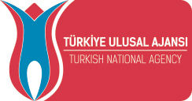
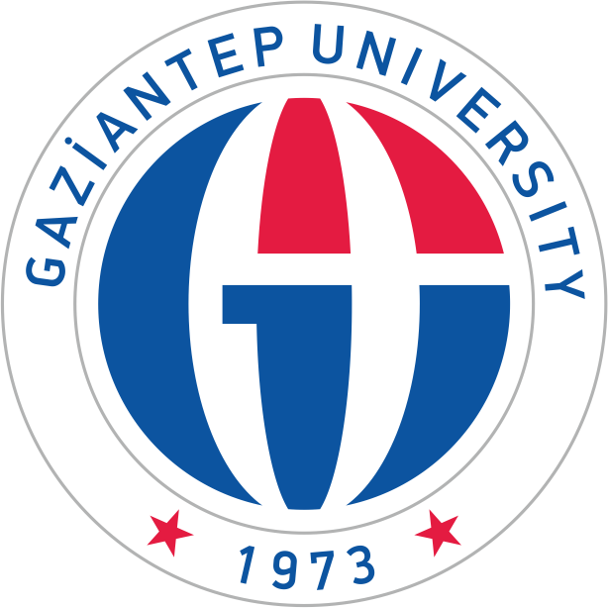
ANNOUNCEMENT
for
ERASMUS+ INTERNATIONAL CREDIT MOBILITY (ICM)
With
GAZIANTEP UNIVERSITY in TURKEY

Dear Faculty Members and Administrative Staff at UTG!

The 1st call for application period for Academic Staff Mobility for Teaching to non-European countries (2018-20 project) has been launched. Applications will be taken between 15 May 2019 to 30 June 2019.
Mobility activities within the framework of this call must take place until 1 May 2020.

Erasmus+ KA107 Staff Mobility for Teaching Assignments (STA) and Staff Mobility Training (STT) is a fully funded mobility activity that allows academic staff of a Higher Education Institution (HEI) to teach and carry out joint academic/educational activities at a partner HEI in the program countries around the globe.
Application Conditions (Minimum Requirements)

Applicants must be a member of UTM and they must be actively working at UTM at the time of application,
For STA:
Applicants must be employed for teaching and lecturing at UTM at Faculty of Medicine, Faculty of Engineering.
For STT:
Applicants must be employed at International Relations Erasmus+ Office at UTM
Applicants are expected to get in touch with:
incetahtaci@gantep.edu.tr in order to contact with the related department and receive an acceptance letter or confirmation e-mail prior to the application deadline (30 June 2019).
Required Documents
- Application form
- Copy of ID card
- English Exam Result (UTG is responsible from the exam)

Announcement Date: 01.04.2019
Application form: http://erasmusicm.gantep.edu.tr/pages.php?url=application-form-for-incoming-students-7
For detailed information about budget and ICM: http://erasmus.gantep.edu.tr/pages.php?url=icm-k-107-35

