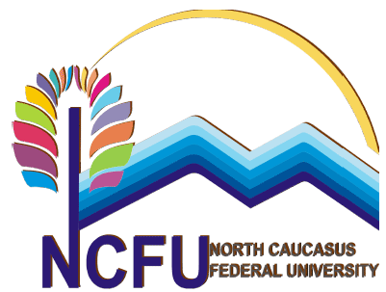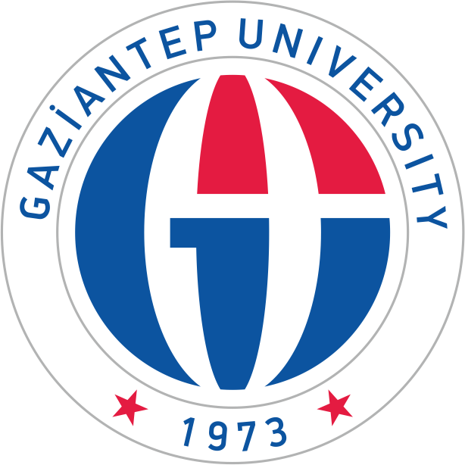
ANNOUNCEMENT
for
ERASMUS+ INTERNATIONAL CREDIT MOBILITY (ICM)
with
North Caucasus Federal University in Russia

Application is for the period of 2019-2020 Academic Years. (one semester)
Application* Criteria:
* Available for Food Engineering and Civil Engineering students only

Students can apply for Erasmus+ International Credit Mobility only if:

- GPA is at least 2.20 as of the application deadline (1ST cycle)
- Minimum score of 30 in language exam
Selection Criteria:
% 50 of GPA + % 50 of Language score
Apply to Erasmus Departmental Coordinators with necessary documents:
-Application form
-Copy of ID card
-Transcript as of the application deadline
- English Exam Result (2017-18-19 YDS, YÖK DİL, GAUN, TOEFL)
- Medical Report (for disabled students)
Applicants with disabilities (approved by medical report) get 10 additional points.

Announcement Date: 28.02.2019
Application Dates: 20.03.2019 - 05.04.2019
Application form: http://erasmusicm.gantep.edu.tr/pages.php?url=application-form-for-incoming-students-7
For detailed information about budget and ICM : http://erasmus.gantep.edu.tr/pages.php?url=icm-k-107-35

